**Milestone 2: Data Collection & Extraction from Database**

Data collection is the process of gathering and measuring information on variables of interest, in an

established systematic fashion that enables one to answer stated research questions, test

hypotheses, and evaluate outcomes and generate insights from the data.

**Activity 1: Collect the dataset**

Please use the link to download the dataset:

https://drive.google.com/file/d/1NRrQhbZ8KuzpkvXl9C6MBzFrXg2sE- J6/view?usp=share_link

**Solution:**

**We collected the data set**

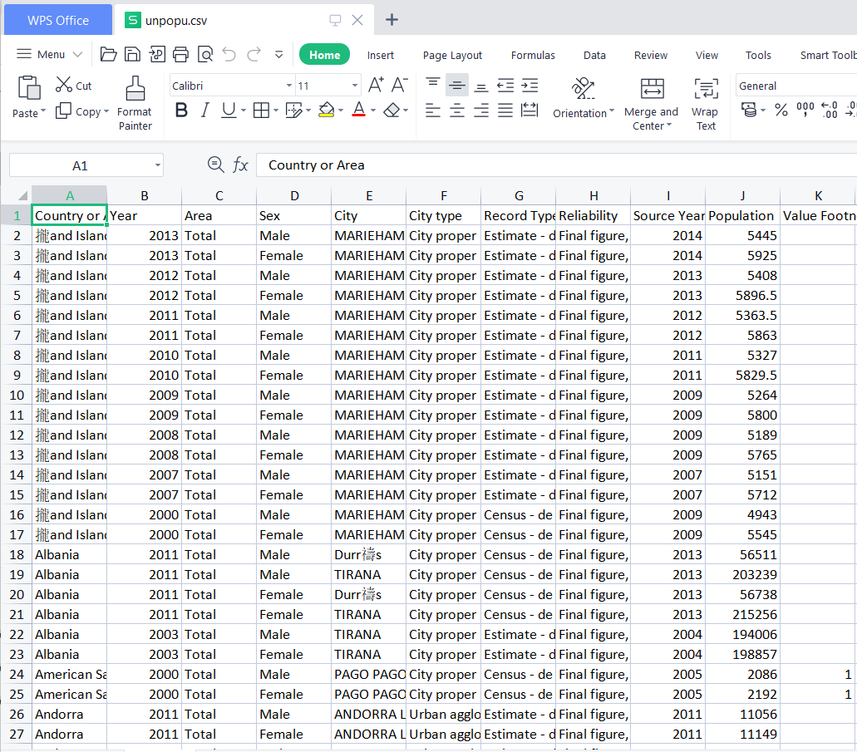

**Activity 2: Storing Data in DB & Perform SQL Operations**

Explanation video link:

<https://drive.google.com/file/d/1uUaPt7PE3t-jPk4txwyGsbVDkcXzDwOl/view?usp=sharing>

Solution:

1. We stored the un population data
2. SQL downloaded and installed

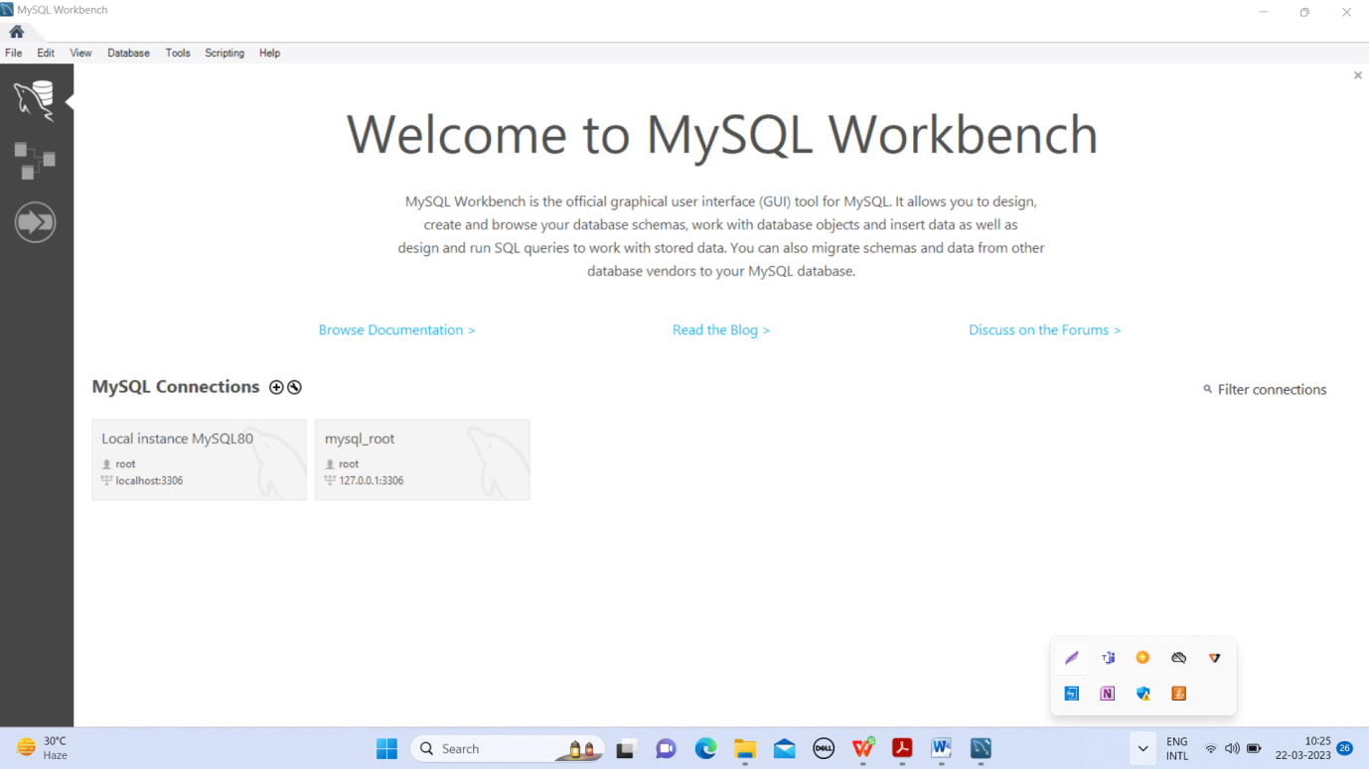

**Activity 3: Connect DB with Tableau**

Explanation video link:

<https://drive.google.com/file/d/11uLSwvMxLVtZdHCkvdSWfRZjriMvaQJB/view?usp=share_lin>

Solution:

We installed tableau and workbench.

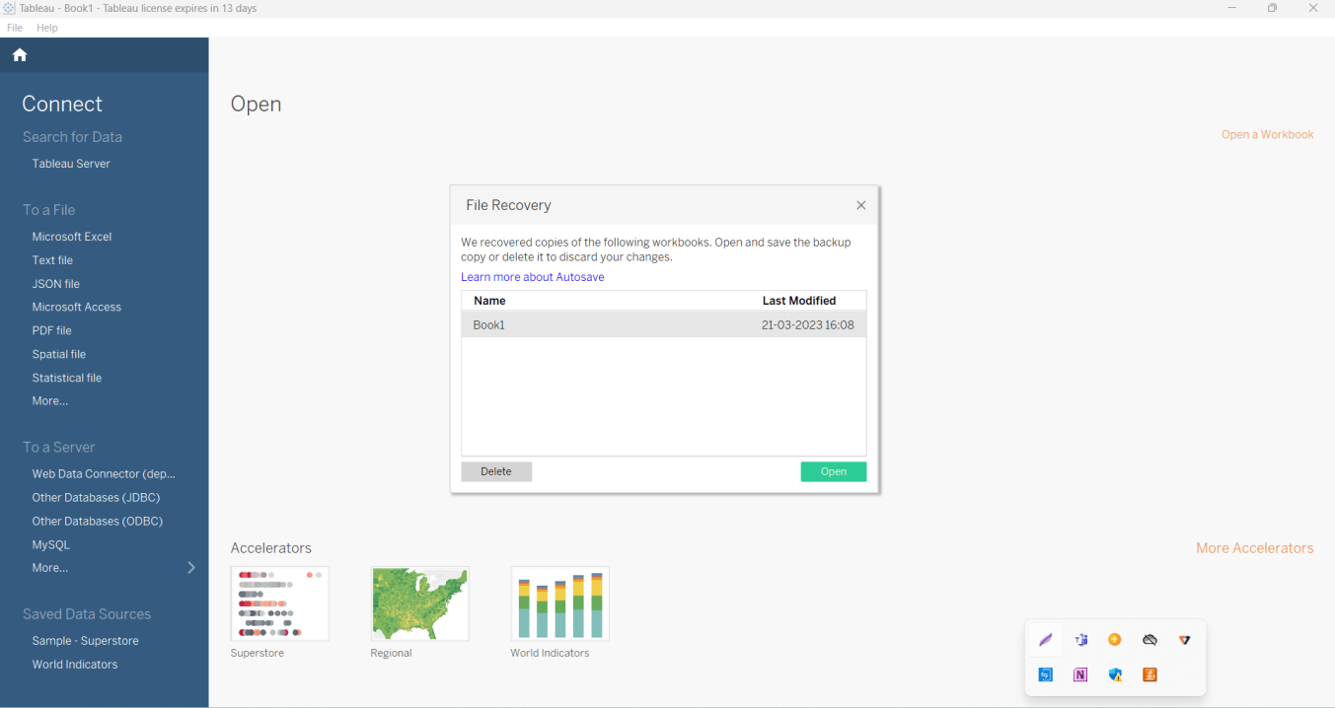

We open our UN population file and draw the first picture.

